JIM PREPARATORY NURSERY & PRIMARY SCHOOL

IKI-IKI

MOTTO: OUR GOD IS ABLE

**TERM TWO ASSEAAMENT EXAMS SET V 2023**

**PRIMARY THREE**

**MATHEMATICS**

**DURATION: 2HRS 30 MIN**

NAME: ..................................................................................

STREAM: ..............................................................................

**INSTRUCTIONS:**

1. Read well and answer all questions.

2. You must write well.

3. Show all the working.

**SECTION: A (40 marks)**

1. Add;

+ =

2. Circle the smallest number.

215 , 251 , 125

3. Work out:

- 3 = 9

4. Write the place value of 6 in the number below.

2 6 7 4

5. How many triangles are in the figure below.

_________________

6. Multiply;

3 0 4

X 2

7. Complete;

One hour = ________ minutes

8. Write in figure;

Two thousand twenty three.

9. Subtract;

6 9 2 0 litres

- 1 4 5 0 litres

10. What number comes after 559?

_________

11. Expand using values;

985 =

12. Shade P $∪$ Q on the venn diagram below.

P Q

13. Write as repeated addition.

3 x 4 is the same as ____ + ___ + ___ = ____

14. Work out;

Francis had 94 guavas. He gave away 47 to Kevina. How

many guavas did he remain with?

15. Name the solid shape below.

_____________

16. Divide;

3 1 8

17. Represent 3704 on the abacus below.

Th H T O

18. Find the sum;

2 3 4

5 1 6

19. A trader has Sh. 7000. He sells his mangoes and gets

Sh. 2500 more. How much money does he have

altogether?

20. Write 15 as Roman numerals.

**SECTION B (60 marks)**

21(i) M = { a , e , i , o , u }

Find the number of members in set M.

(ii) Study the Venn diagram and answer the questions

below.

F G

1 2 6

3 5 4 8

a) List the members of set F.

b) Find F $∩$ G

(c) How many members are in both sets?

22. Work out and answer correctly.

(a) Ann had 475 bags of G.nuts, 39 bags got rotten.

How many bags did she remain with?

(b) If there are 7 days in a week. How many days are

there in 4 weeks?

(c) Peter’s water tank holds 138litres. Jack’s tank

holds 526 litres of water. Find the total capacity

in the two tanks.

23(a) Shade $\frac{7}{8}$

(b) Name the unshaded fraction.

(d) Work out;

- =

24. Find the missing number.

a) 1 , 5 , 9 , ____

b) 60 , 55 , 50 , ____

c) 8 + = 12

25. **Study the diagram below and answer the questions**

**that follow.**

**HOME**

**SCHOOL**

**MARKET**

16 metres 30 metres

52 metres

(a) How many metres are between home and school?

(b) Paul walked from home to the market and

continued to school. How many metres did he walk

altogether?

(c) Work out;

1 6 metres

3 0 metres

$+$ 5 2 metres

26(a) Show a quarter past 6 on the clock face below.

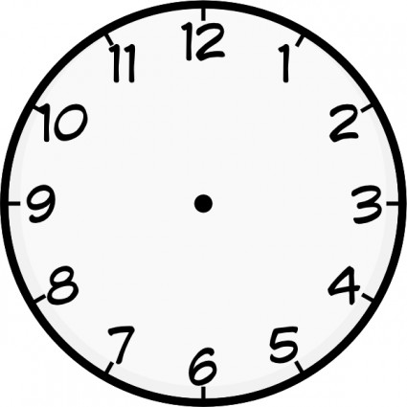

(b) Write the number of days for the months below;

April - ________

May - _________

June - _________

27. Work out using a number line.

a) 2 $+$ 7 = ____

---0 1 2 3 4 5 6 7 8 9 10 ---

(b) 5 $-$ 4 = _____

---0 1 2 3 4 5 6 7 8 9 10 ---

28. Complete the table below.

|  |  |  |  |  |  |
| --- | --- | --- | --- | --- | --- |
| Number of stools | 1 | 2 | ____ | 4 | ___ |
| Number of legs | 3 | ____ | 9 | ___ | 15 |

29. John has Sh. 500 and Jacob has Sh. 5,000.

(a) Who has more money?

(b) If John buys a sweet of Sh. 200. How much money

will he remain with?

(c) How many one thousand shilling notes make five

thousand shillings?

(d) Find the total amount.

Sh. 5 0 0 0

Sh. 5 0 0

30. Work out and complete the diagram.

9

6 2

3

____

18

___ ___

____

31. Draw the shapes named below.

|  |  |  |
| --- | --- | --- |
| cylinder | rectangle | oval |
|  |  |  |

32. **The graph below shows the number of pupils who**

**played games in P.3 class. Use it to answer the**

**questions that follow.**

Number of pupils

**Football Volleyball Netball Tennis**

25

20

15

10

5

0

|  |  |  |  |
| --- | --- | --- | --- |
|  |  |  |  |
|  |  |  |  |
|  |  |  |  |
|  |  |  |  |
|  |  |  |  |

(a) How many pupils played football?

(b) Which games are played by the same number of

pupils?

(c) How many games were played altogether?

(d) Find the total number of pupils who participated in

all the games.

**End**